GitHubDocument

1. Signup / Sign in for GitHub Browser.

Register for GitHub if you're a new user

1. [Signup](https://github.com/signup?ref_cta=Sign+up&ref_loc=header+logged+out&ref_page=%2F&source=header-home) for GitHub to create an account in GitHub.

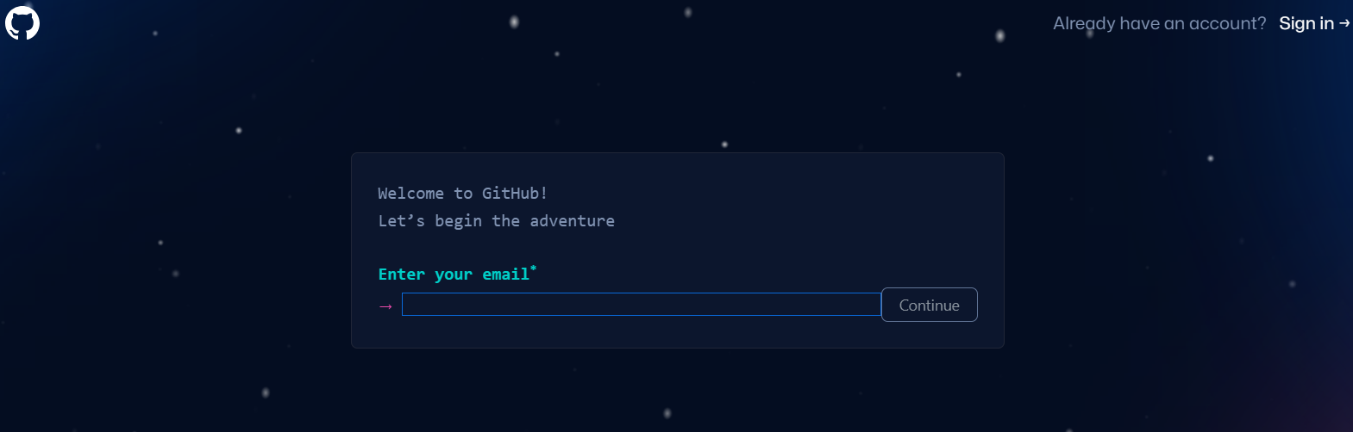

1. Enter **Email Id** and Click on **Continue**

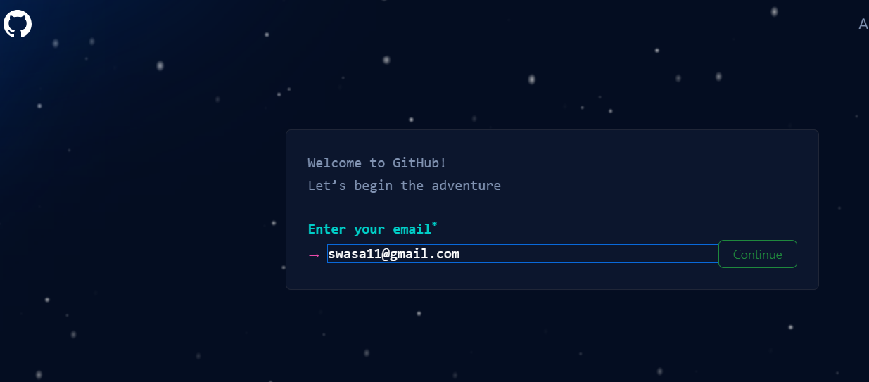

1. Click **Continue** after **entering each detail** to get a verification. Select **Verify**.

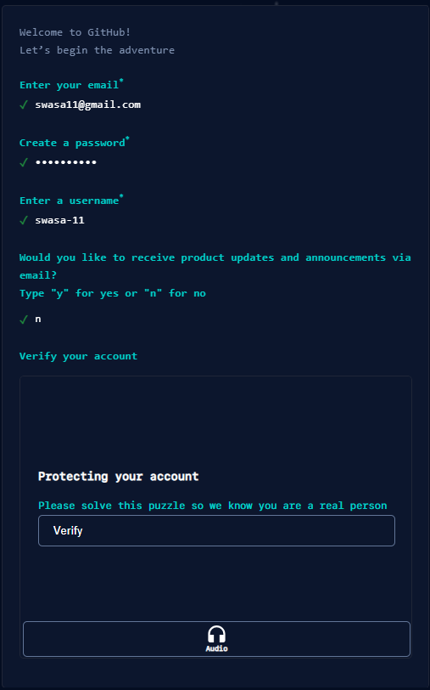

1. To confirm your account, **turn** the **animal** in the **hand's direction**. Select **Create Account**.

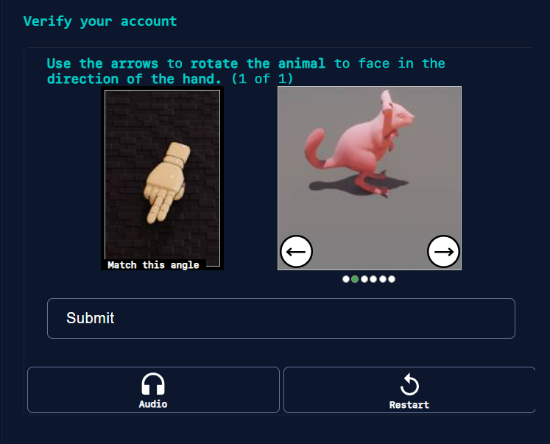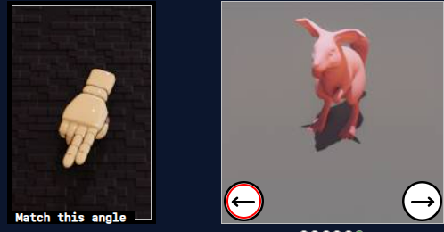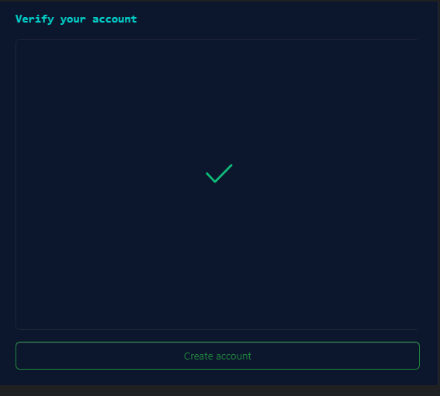

1. **Input** the **code** that was **delivered** to you **through email**.

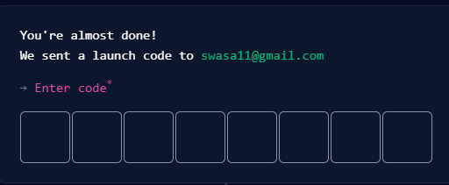

1. **Choose** the **options** **if require** **else** click on **skip personalization**.

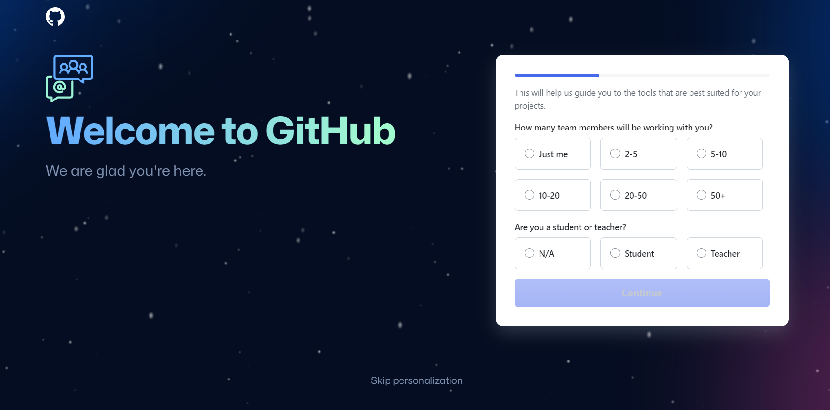

**Sign in after Signup, or if you're already a member of GitHub.**

1. [Sign](https://github.com) in to GitHub.

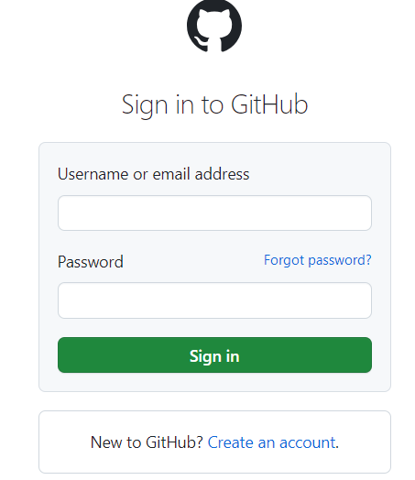

# II Process to Create Repository

1. Search for **vajrang-b.**

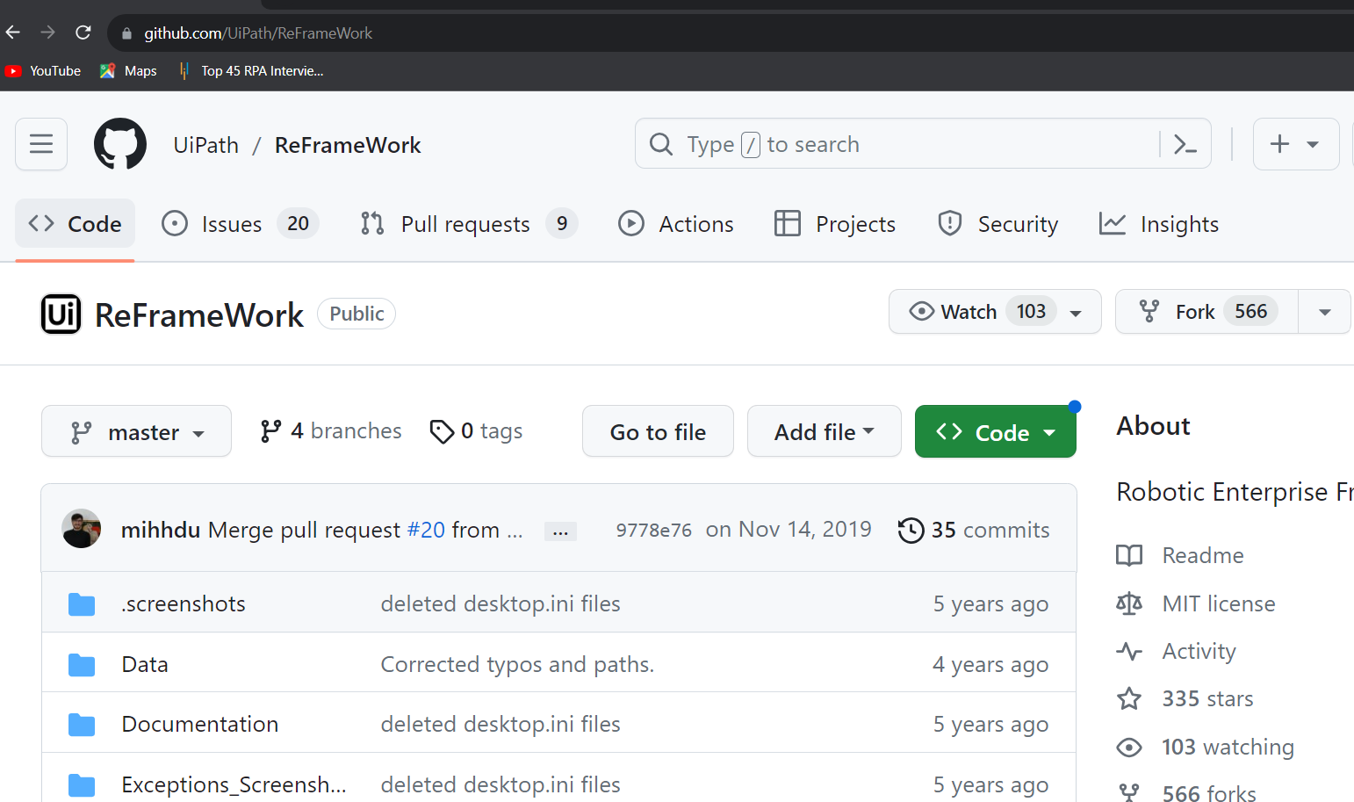

1. Click on **Users.**

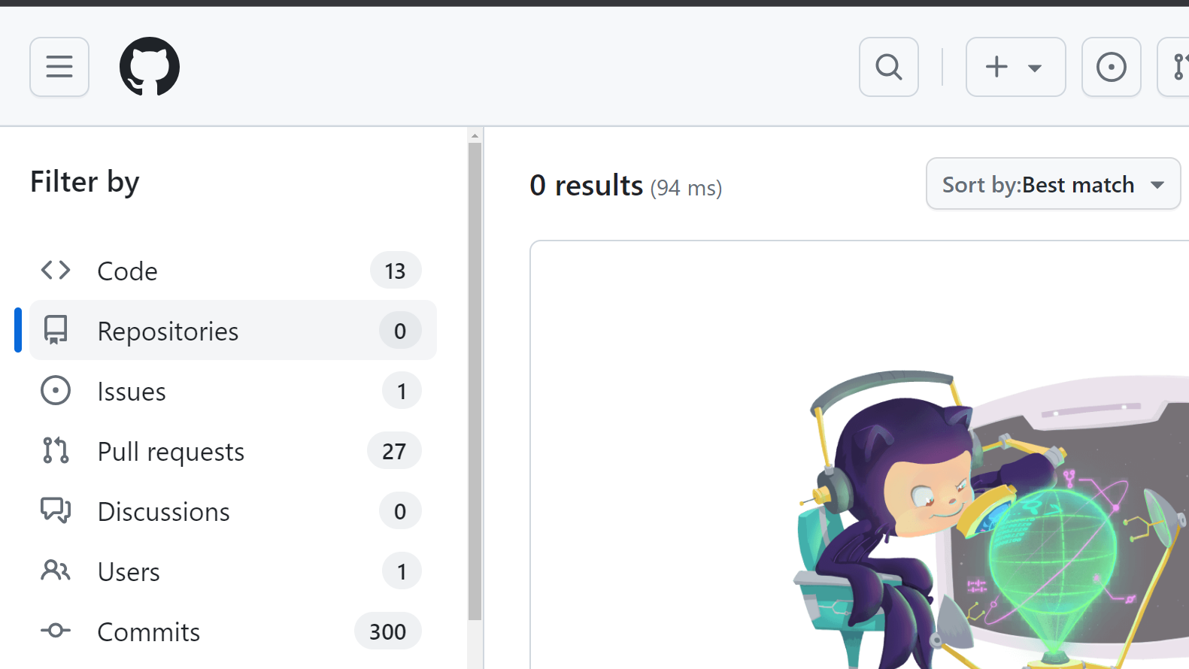

1. Click on **Vajrang vajrang-b.**

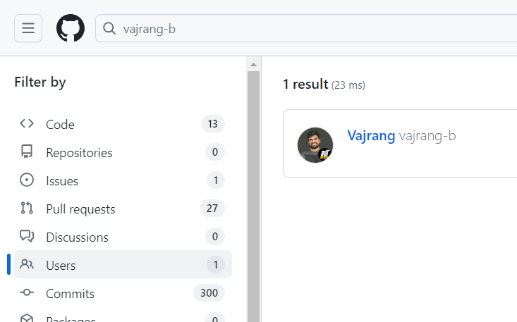

1. You will be led to the following Repository after clicking on Vajrang Vajrang-b. choose **RPA-Developer-in-30-Days.**

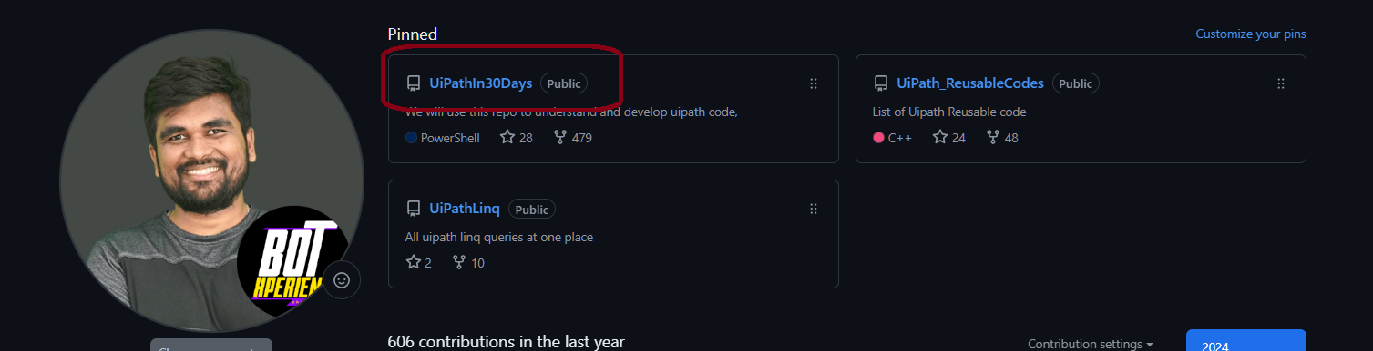

1. Click on **Fork**.

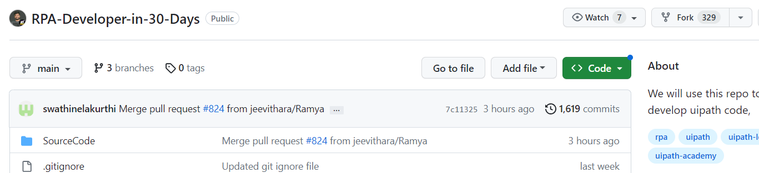

1. Click on **Create Fork**.

￼

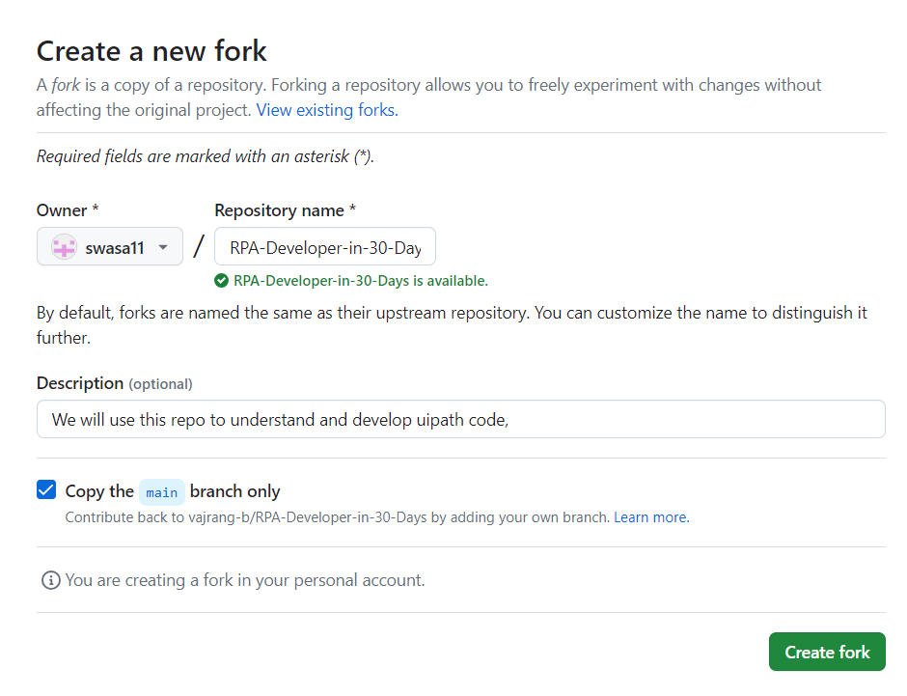

1. **Your Name / RPA-Developer-in-30-Days** should appear after clicking Create Fork, as shown below

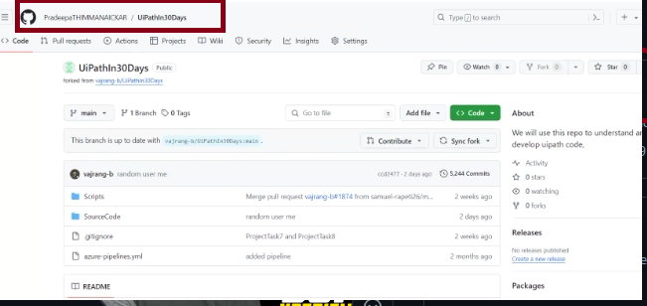

# III GitHub Desktop

# Clone to Your Repository

1. Download and install [GitHub Desktop](https://desktop.github.com/)
2. Launch **GitHub Desktop**, select the **refresh** option to update the interface. Once the refresh is completed, your repository will be displayed. Choose **your repository** from the list, and you'll find the option to clone it. Click on the "**Clone your repository**" option to proceed.

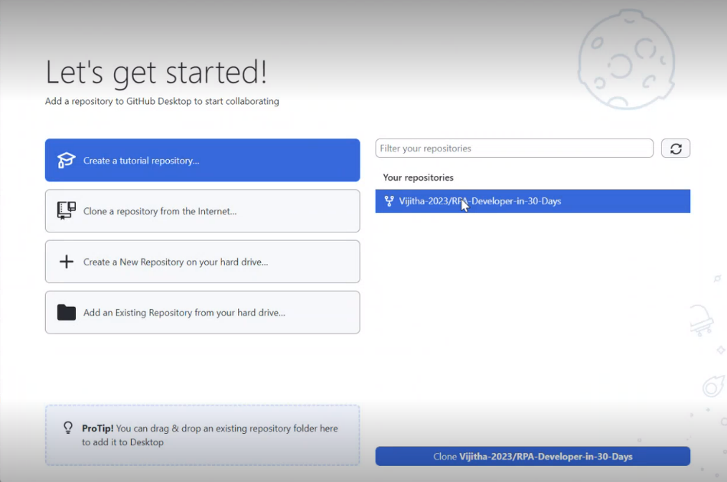

1. After clicking "Clone your repository," you will encounter the following window for cloning. **Choose** your desired **Local path**, then proceed by clicking the "**Clone**" button

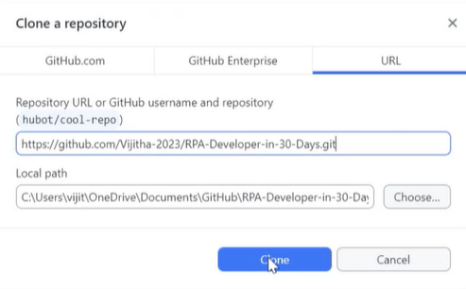

1. Upon successfully completing the cloning process, the following panel will be presented. Proceed by selecting the "**Continue**" option.

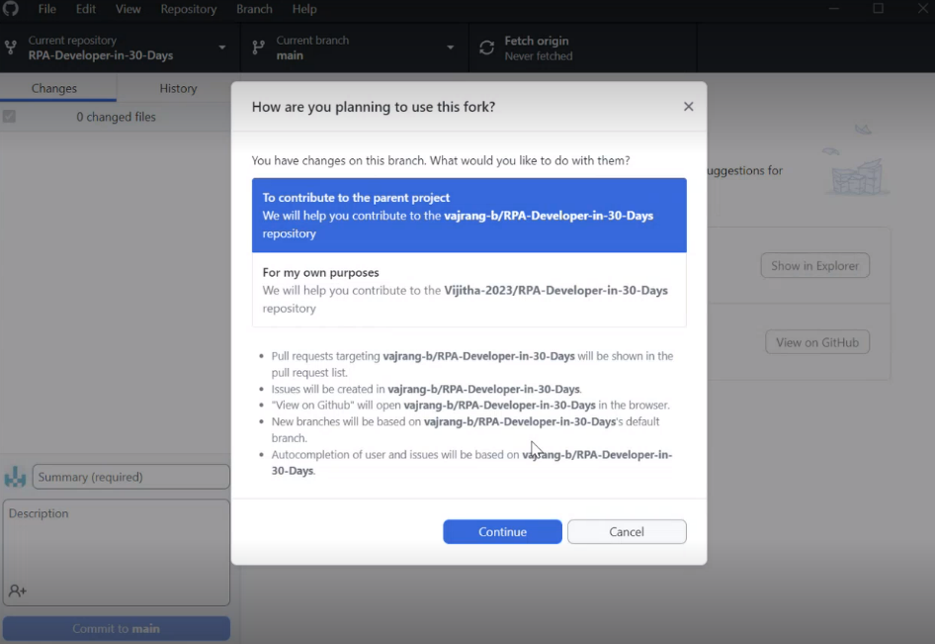

# How to Commit Changes in GitHub Desktop?

1. Click on **Show in Explorer**.

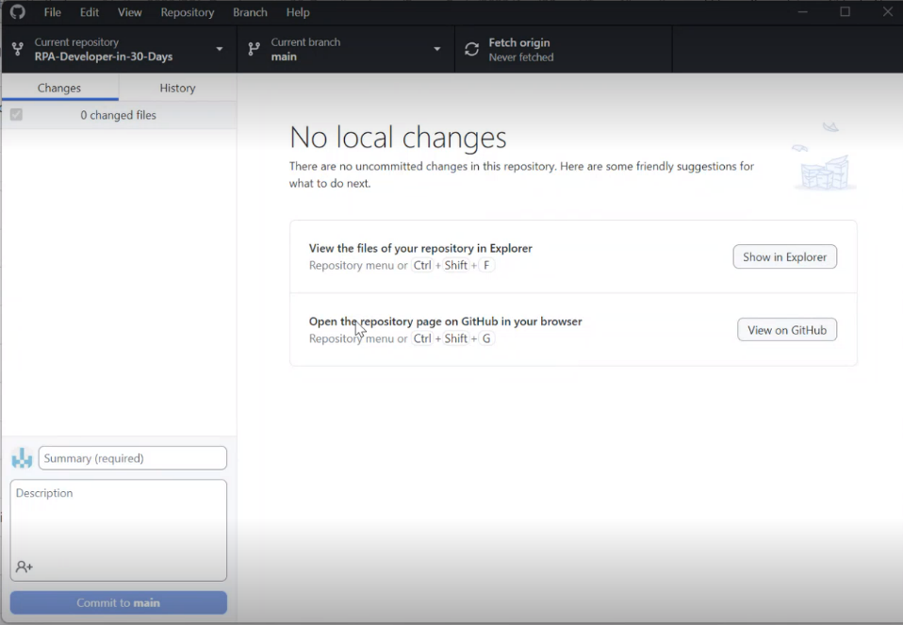

1. After clicking "Show in Explorer," you will be directed to the local path you chose during the cloning process. Within this location, you'll find the source code. Navigate to the "**SourceCode**" section, then choose the appropriate "**Year**" and select the **training month**.

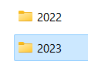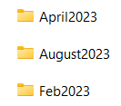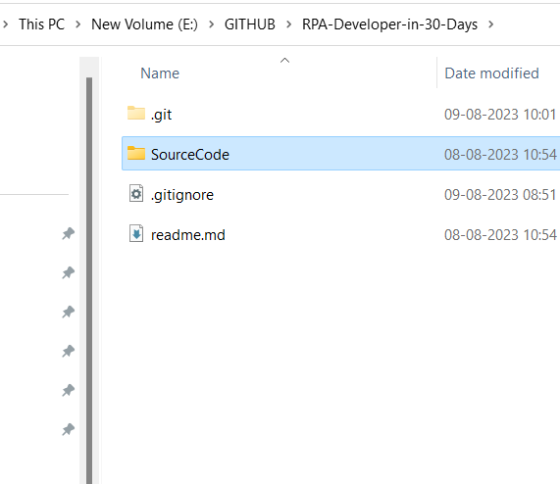

1. In the month that you are taking training, make a **folder** with your name in it. Let's assume that you will be attending training in August. Create a folder inside the August 2023 folder with **your name** on it.

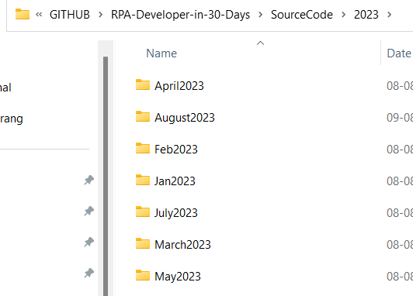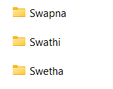

1. Once you have **completed** developing your **Task**, **put** that **Task/Code** inside **your folder**. Here in below picture we have folder named swathi. In that we created a Sample text file with some information.

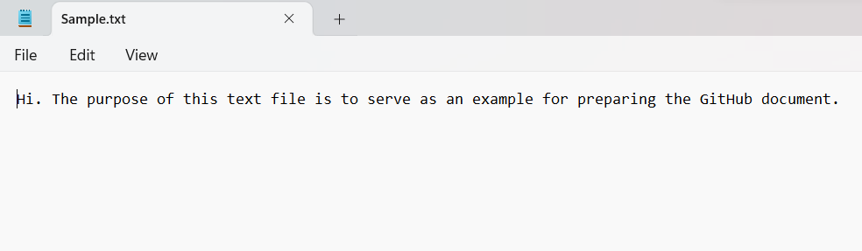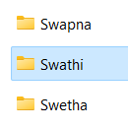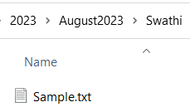

1. Then go to GitHub Desktop and the changes will be appeared as shown

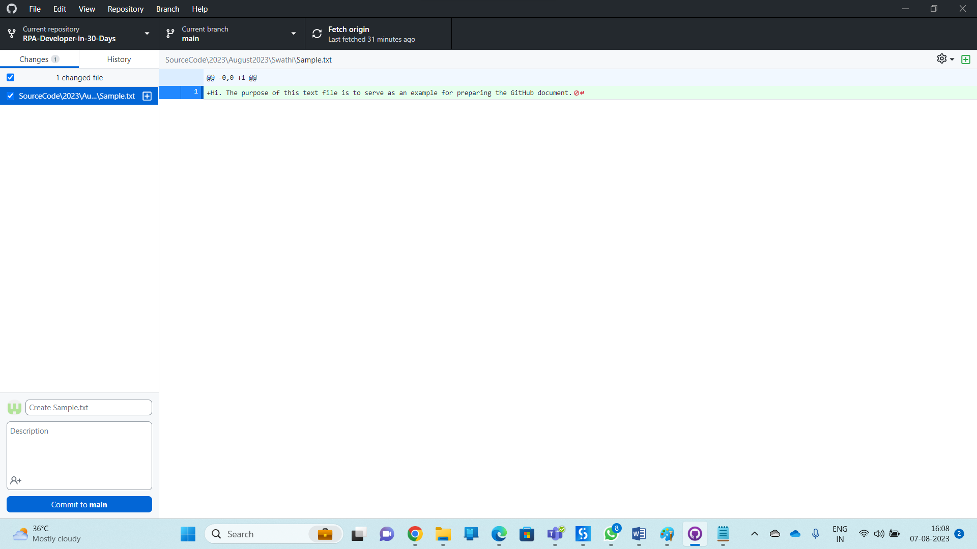

1. Commit those changes by providing **summary** and **description** on what changes you have performed on the code. Click on **Commit**.

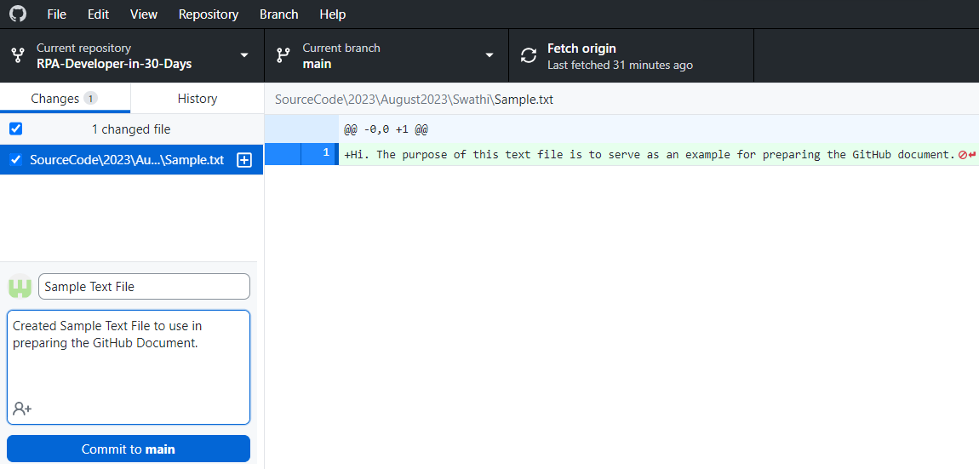

# IV Making Pull Request in GitHub Browser

## How to Push Code and make a Pull Request in GitHub Browser?

1. Click on **Push origin**. Click on **View on** **GitHub**.

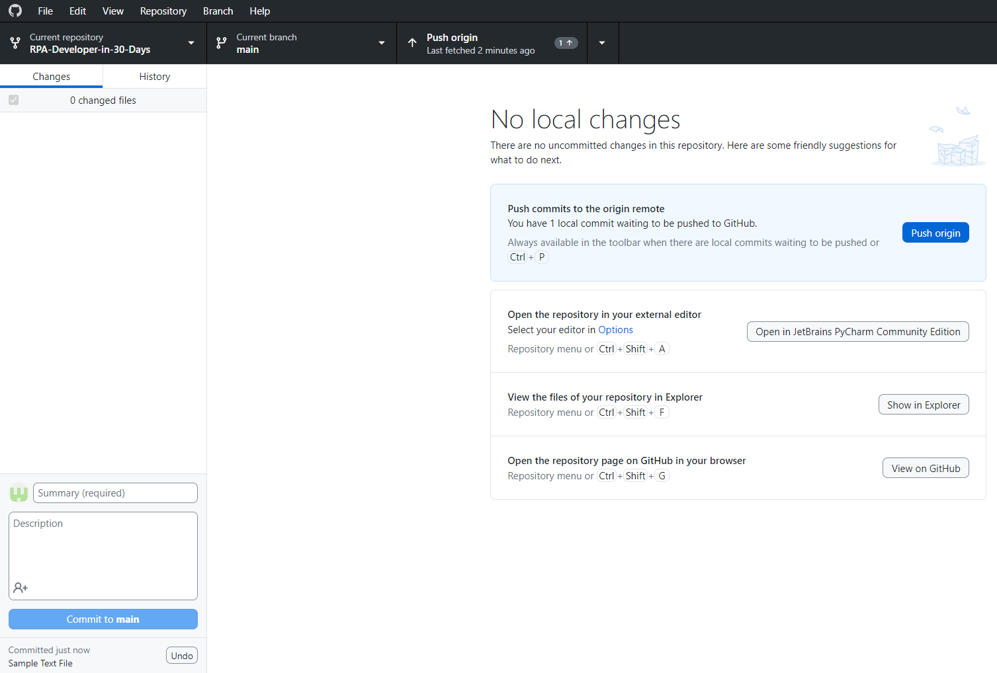

1. Click on **Fork drop down.** Select **your Repository**.

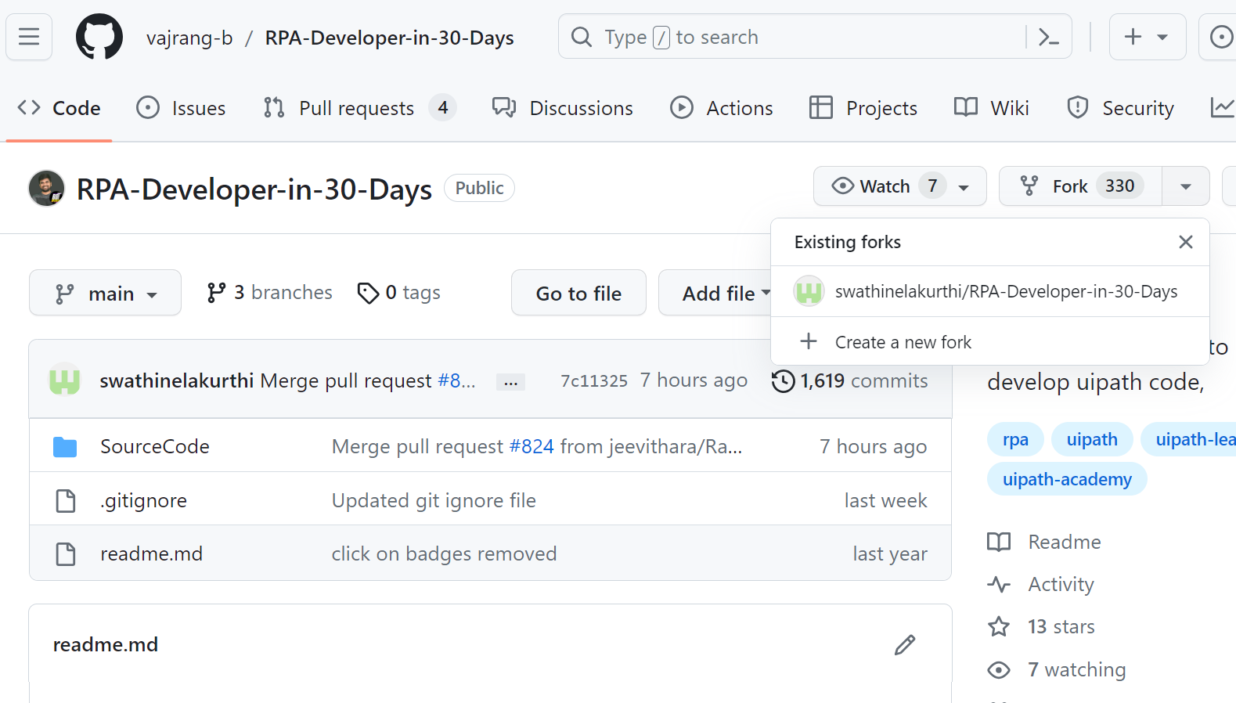

1. Click on **Pull requests**.

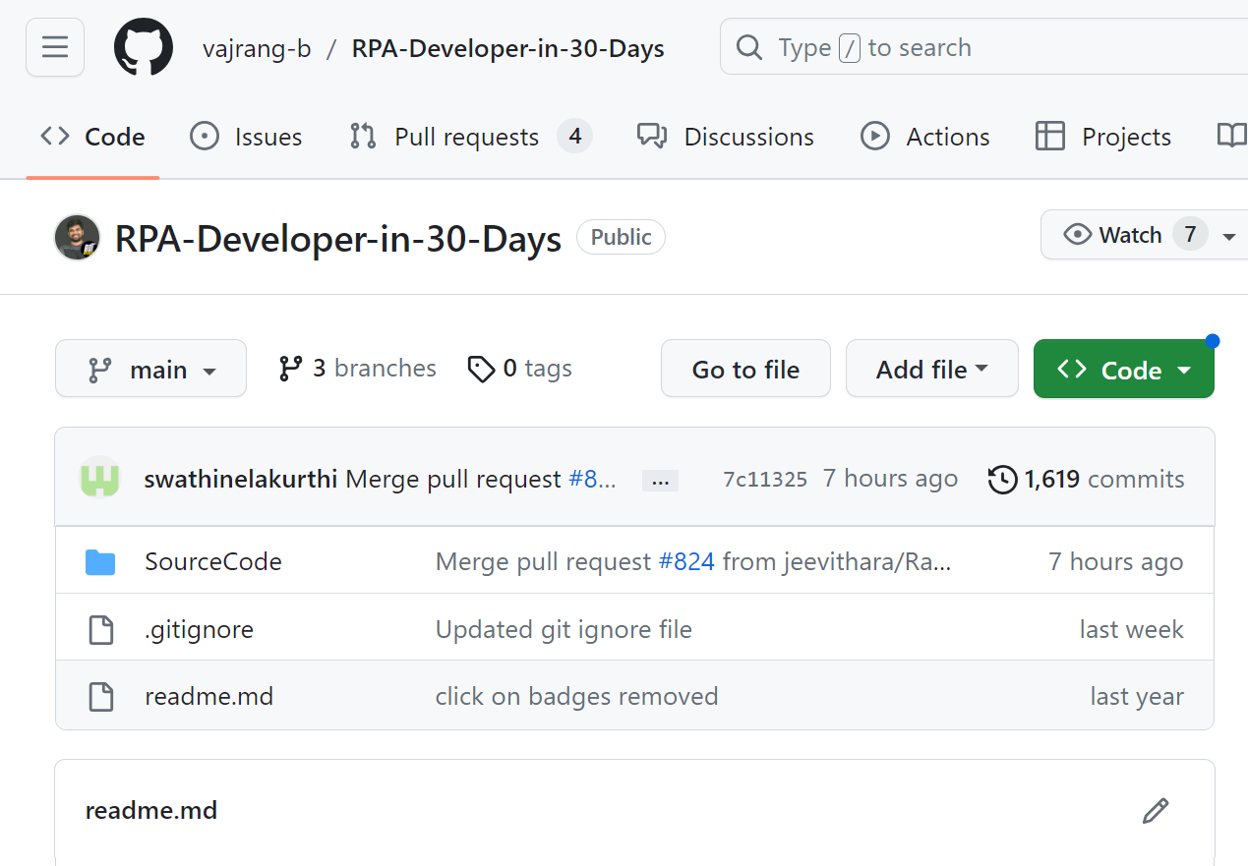

1. Click on **New pull request**

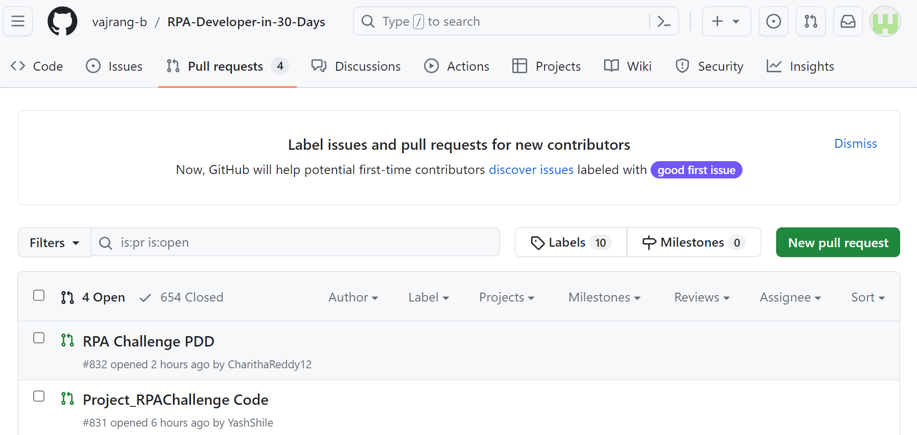

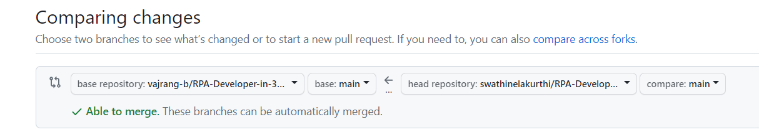

Here Swathi is Pushing the code to vajrang repository then Swathi repository must be in Head Repository and the receiving repository i.e., Vajrang Repository should be base.

1. Click on **Create pull request**.

￼

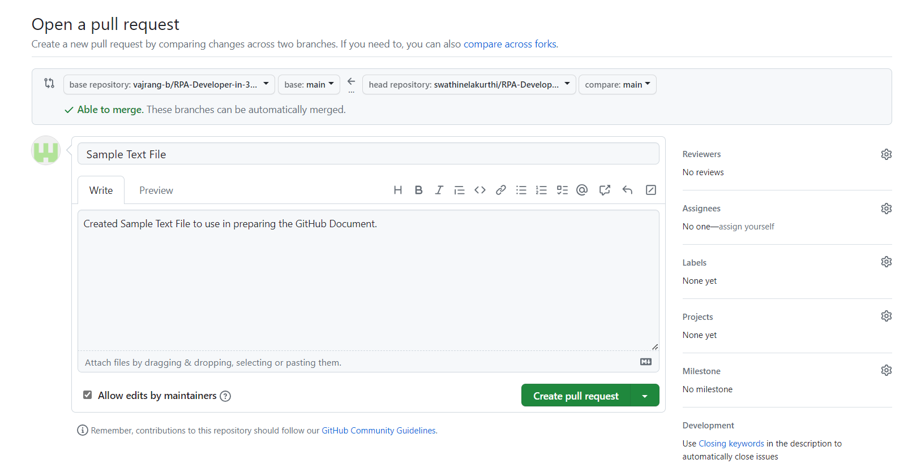

* The pull request serves as a container for the proposed changes. It includes information about the changes, comments, descriptions, and, in some cases, automated tests or checks.
* Other developers, maintainers, or collaborators can review the pull request. They can leave comments, suggest improvements, and approve or reject the proposed changes.
* During the review process, discussions can take place within the pull request, allowing developers to address concerns and iterate on the code.

# How to Pull Other’s Code changes to your Source Folder?

1. From GitHub Desktop go to **GitHub Browser** by clicking on **View on GitHub**

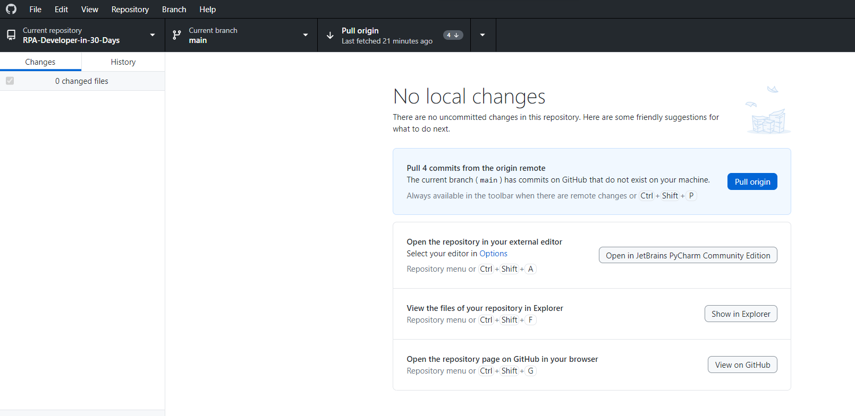

1. Click on **drop down arrow at Fork** and Select **your repository**

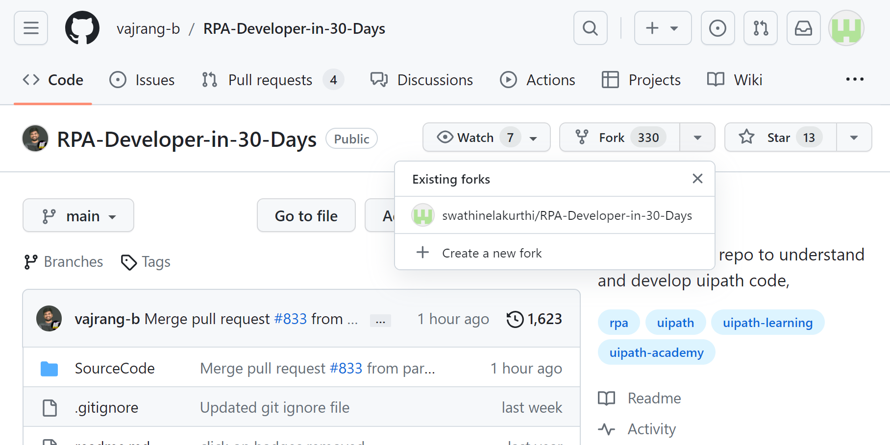

1. Click on **Sync Fork**. Click on **Update branch.**

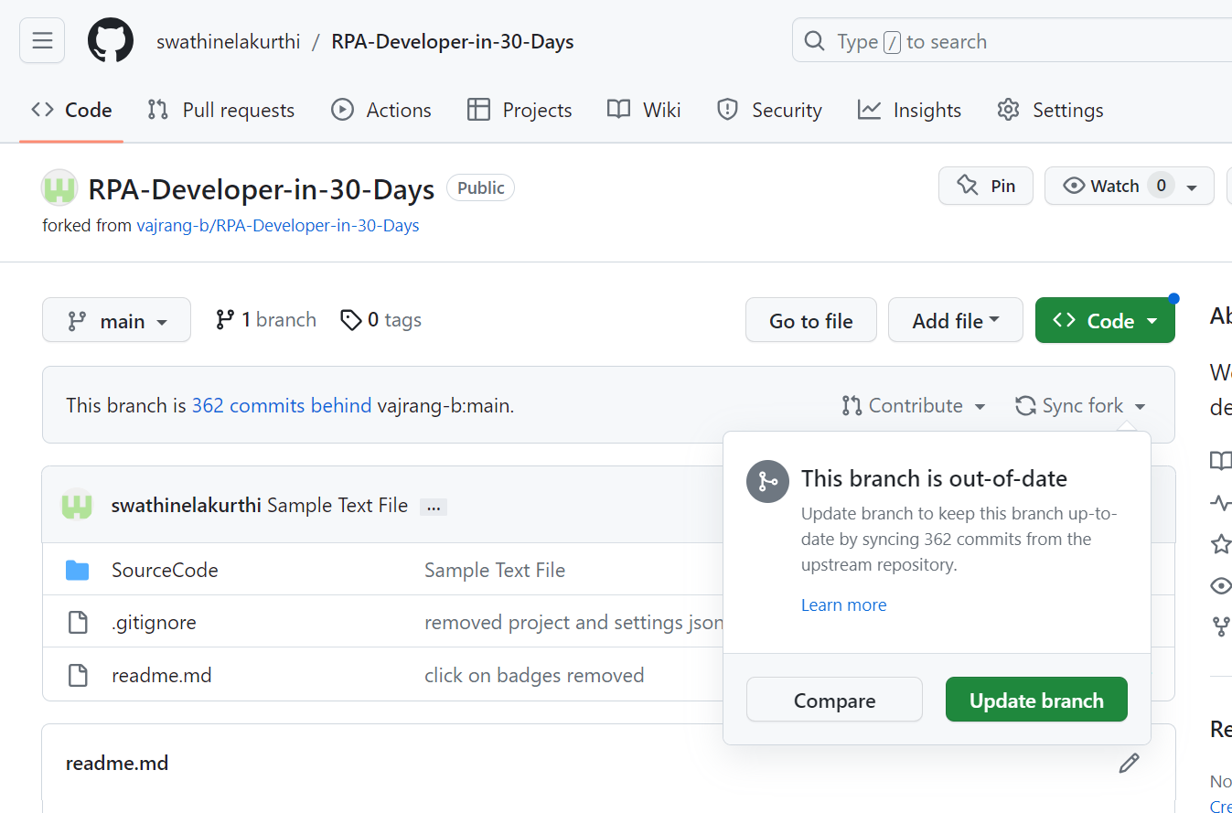

1. Go to **GitHub Desktop**. Click on Pull Origin. Click on **Show in Explorer**. You can find other’s codes in the SourceCode folder>Year>Month (e.g. SourceCode\2023\August2023)

